**Lab Manual**

**Step 1. Download the installer**

Go to the [Git For Windows](https://gitforwindows.org/) website and click on the [Download] button to download and save the installer. Once downloaded double-click on the .exe file to begin installation.

**Step 2. License Information**

To accept the License Agreement click [Next >]

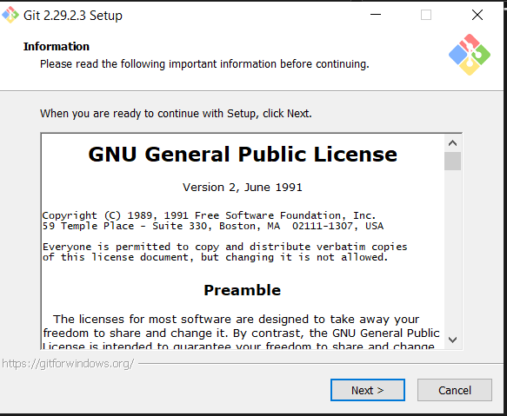

**Step 3. Select Installation Folder**

I recommend selecting a directory path with no spaces in the name, as in the illustration below  
[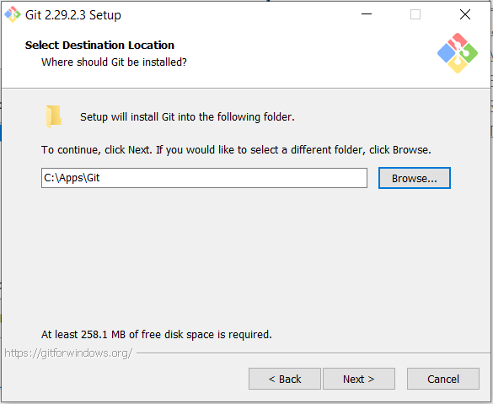](http://robertovormittag.net/wp-content/uploads/2016/02/gw02.png)

**Step 4. Select Components**

Select the following components and file associations, then click [Next >]  
[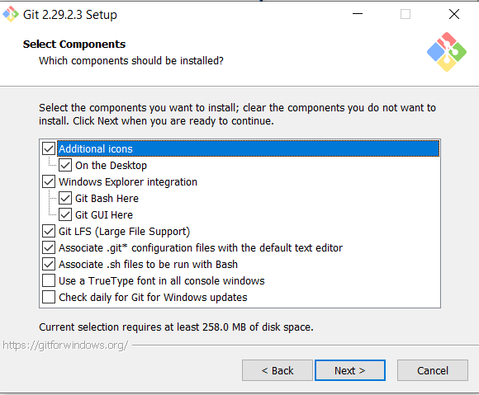](http://robertovormittag.net/wp-content/uploads/2016/02/gw03.png)

**Step 5. Select Start Menu Folder**

Accept the suggested name and click [Next>]  
[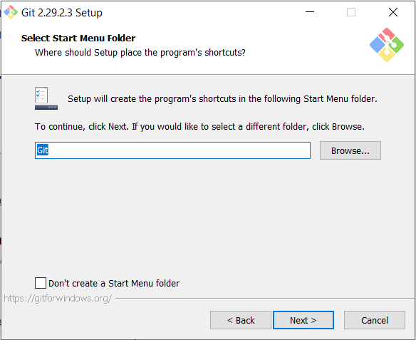](http://robertovormittag.net/wp-content/uploads/2016/02/gw04.png)

**Step 6. Choose Default Editor**

This will determine which text editor will open to input commit notes and other text messages interactively. Go for Nano if you are not familiar with more powerful editors like Vim  
[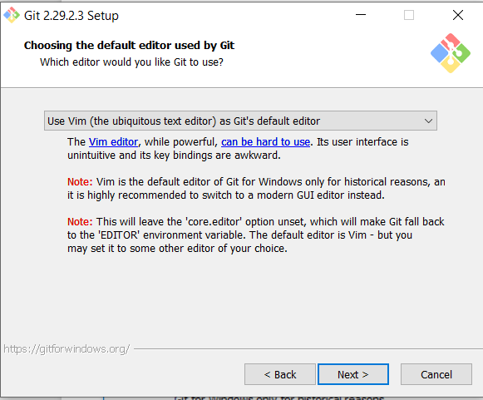](http://robertovormittag.net/wp-content/uploads/2016/02/gw05.png)

**Step 7. Select Default Branch Name**

Let Git decide and click [Next>]  
[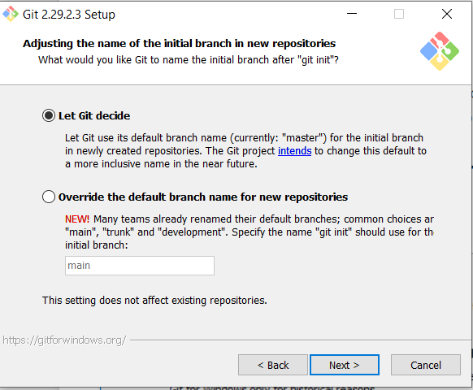](http://robertovormittag.net/wp-content/uploads/2016/02/gw06.png)

**Step 8. Adjust PATH Environment**

Make sure you select “Use Git from Git Bash only”  
[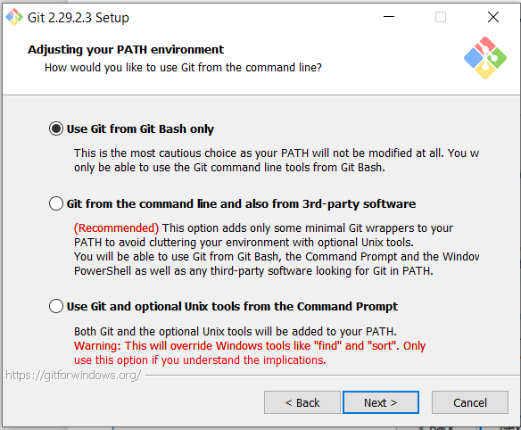](http://robertovormittag.net/wp-content/uploads/2016/02/gw07.png)

**Step 9. Select HTTPS transport**

Specify the library to use for secure HTTP connections. Go for OpenSSL unless you have a reason to do otherwise  
[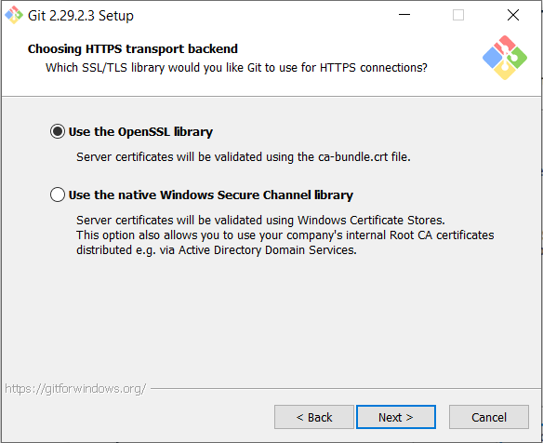](http://robertovormittag.net/wp-content/uploads/2016/02/gw08.png)

**Step 10. Configure Line Ending Conversions**

Make sure you select “Checkout Windows-style, commit Unix-style line endings”  
[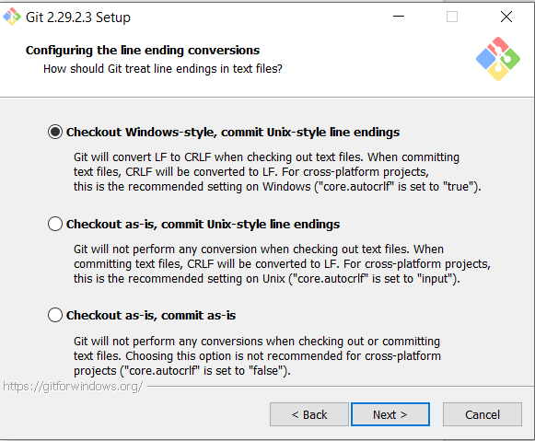](http://robertovormittag.net/wp-content/uploads/2016/02/gw09.png)

**Step 11. Select Behaviour of Pull Command**

Select Default  
[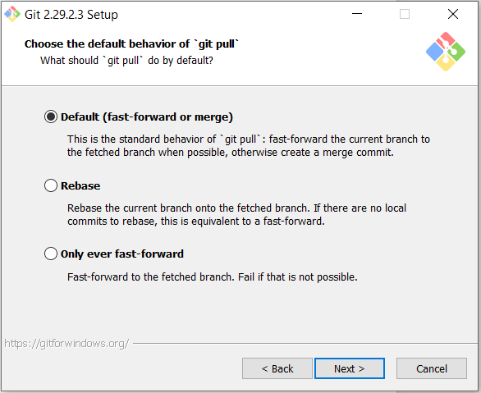](http://robertovormittag.net/wp-content/uploads/2016/02/gw11.png)

**Step 12. Select Credential Helper**

Go with the recommended choice  
[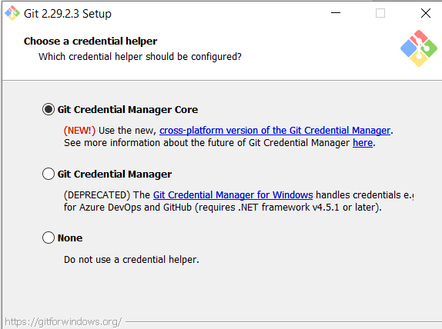](http://robertovormittag.net/wp-content/uploads/2016/02/gw12.png)

**Step 13. Configure Extra Options**

Leave unchecked and click [Next >]  
[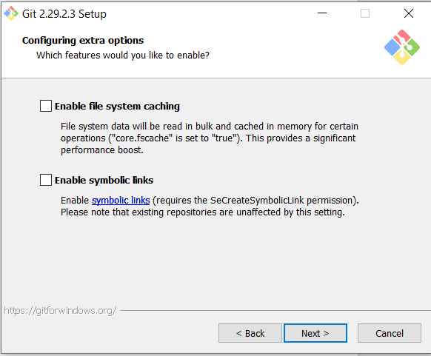](http://robertovormittag.net/wp-content/uploads/2016/02/gw13.png)

**Step 14. Configure Experimental Options**

Leave unchecked and click [Next >]  
[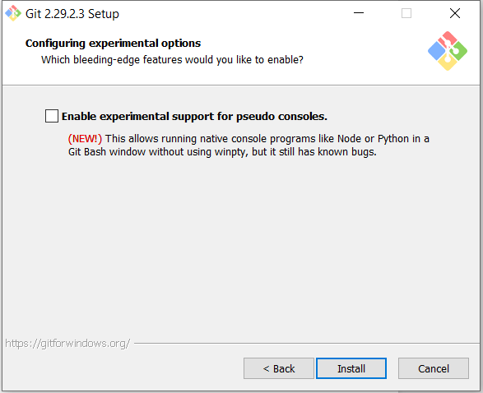](http://robertovormittag.net/wp-content/uploads/2016/02/gw14.png)

**Step 15. Progress Bar**

Installation begins…  
[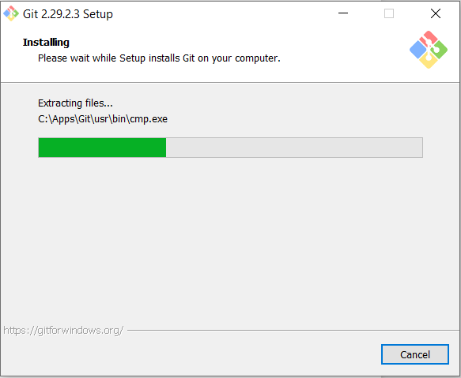](http://robertovormittag.net/wp-content/uploads/2016/02/gw15.png)

**Step 16. Installation Complete**

Click on [Finish]. Congratulations… job done!  
[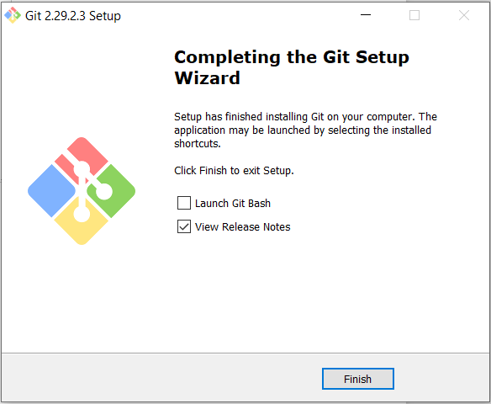](http://robertovormittag.net/wp-content/uploads/2016/02/gw16.png)

**SETUP**

Configuring user information used across all local repositories

* git config --global user.name “[name]” set a name that is identifiable for credit when review version history
* git config --global user.email “[valid-email]” set an email address that will be associated with each history marker

**SETUP & INIT**

Configuring user information, initializing and cloning repositories

* git init initialize an existing directory as a Git repository
* git clone [url] retrieve an entire repository from a hosted location via URL

**STAGE & SNAPSHOT**

Working with snapshots and the Git staging area git status show modified files in working directory, staged for your next commit

* git add [file] add a file as it looks now to your next commit (stage)
* git reset [file] unstage a file while retaining the changes in working directory
* git diff difference of what is changed but not staged
* git diff --staged diff of what is staged but not yet commited
* git commit -m “[descriptive message]” commit your staged content as a new commit snapshot

**BRANCH & MERGE**

Isolating work in branches, changing context, and integrating changes

* git branch list your branches. a * will appear next to the currently active branch
* git branch [branch-name] create a new branch at the current commit
* git checkout switch to another branch and check it out into your working directory
* git merge [branch] merge the specified branch’s history into the current one
* git log show all commits in the current branch’s history

**INSPECT & COMPARE**

Examining logs, diffs and object information

* git log show the commit history for the currently active branch
* git log branchB..branchA show the commits on branchA that are not on branch
* git log --follow [file] show the commits that changed file, even across renames
* git diff branchB...branchA show the diff of what is in branchA that is not in branch

**SHARE & UPDATE**

Retrieving updates from another repository and updating local repos

* git remote add [alias] [url] add a git URL as an alias
* git fetch [alias] fetch down all the branches from that Git remote
* git merge [alias]/[branch] merge a remote branch into your current branch to bring it up to date
* git push [alias] [branch] Transmit local branch commits to the remote repository branch
* git pull fetch and merge any commits from the tracking remote branch

**TRACKING PATH CHANGES**

Versioning file removes and path changes

* git rm [file] delete the file from project and stage the removal for commit
* git mv [existing-path] [new-path] change an existing file path and stage the move

Project commands:

USER@LAPTOP-PVTV5A3O MINGW64 ~

$ pwd

/c/Users/USER

USER@LAPTOP-PVTV5A3O MINGW64 ~

$ cd D:

USER@LAPTOP-PVTV5A3O MINGW64 /d

$ mkdir eduplatform

USER@LAPTOP-PVTV5A3O MINGW64 /d

$ cd eduplatform

USER@LAPTOP-PVTV5A3O MINGW64 /d/eduplatform

$ git init

Initialized empty Git repository in D:/eduplatform/.git/

USER@LAPTOP-PVTV5A3O MINGW64 /d/eduplatform (master)

$ vi index.html

USER@LAPTOP-PVTV5A3O MINGW64 /d/eduplatform (master)

$ vi style.css

USER@LAPTOP-PVTV5A3O MINGW64 /d/eduplatform (master)

$ vi script.js

USER@LAPTOP-PVTV5A3O MINGW64 /d/eduplatform (master)

$ vi .gitignore

USER@LAPTOP-PVTV5A3O MINGW64 /d/eduplatform (master)

$ git add index.html

warning: in the working copy of 'index.html', LF will be replaced by CRLF the next time Git touches it

USER@LAPTOP-PVTV5A3O MINGW64 /d/eduplatform (master)

$ git commit -m "Initial setup with base HTML structure for homepage"

[master (root-commit) 7c2d3b8] Initial setup with base HTML structure for homepage

1 file changed, 79 insertions(+)

create mode 100644 index.html

USER@LAPTOP-PVTV5A3O MINGW64 /d/eduplatform (master)

$ git add style.css

warning: in the working copy of 'style.css', LF will be replaced by CRLF the next time Git touches it

USER@LAPTOP-PVTV5A3O MINGW64 /d/eduplatform (master)

$ git commit -m "Add core CSS for overall styling"

[master 961674f] Add core CSS for overall styling

1 file changed, 224 insertions(+)

create mode 100644 style.css

USER@LAPTOP-PVTV5A3O MINGW64 /d/eduplatform (master)

$ git add script.js

warning: in the working copy of 'script.js', LF will be replaced by CRLF the next time Git touches it

USER@LAPTOP-PVTV5A3O MINGW64 /d/eduplatform (master)

$ git commit -m "JavaScript for navigation and hero button"

[master 49c6357] JavaScript for navigation and hero button

1 file changed, 42 insertions(+)

create mode 100644 script.js

USER@LAPTOP-PVTV5A3O MINGW64 /d/eduplatform (master)

$ git add .gitignore

warning: in the working copy of '.gitignore', LF will be replaced by CRLF the next time Git touches it

USER@LAPTOP-PVTV5A3O MINGW64 /d/eduplatform (master)

$ git commit -m "Add .gitignore file "

[master 9d76c39] Add .gitignore file

1 file changed, 17 insertions(+)

create mode 100644 .gitignore

USER@LAPTOP-PVTV5A3O MINGW64 /d/eduplatform (master)

$ vi index.html

USER@LAPTOP-PVTV5A3O MINGW64 /d/eduplatform (master)

$ git add index.html

warning: in the working copy of 'index.html', LF will be replaced by CRLF the next time Git touches it

USER@LAPTOP-PVTV5A3O MINGW64 /d/eduplatform (master)

$ git commit -m "Refine homepage content and hero section"

[master 8aeb1e1] Refine homepage content and hero section

1 file changed, 1 insertion(+), 1 deletion(-)

USER@LAPTOP-PVTV5A3O MINGW64 /d/eduplatform (master)

$ git log --oneline

8aeb1e1 (**HEAD** -> **master**) Refine homepage content and hero section

9d76c39 Add .gitignore file

49c6357 JavaScript for navigation and hero button

961674f Add core CSS for overall styling

7c2d3b8 Initial setup with base HTML structure for homepage

USER@LAPTOP-PVTV5A3O MINGW64 /d/eduplatform (master)

$ vi courses.html

USER@LAPTOP-PVTV5A3O MINGW64 /d/eduplatform (master)

$ vi about.html

USER@LAPTOP-PVTV5A3O MINGW64 /d/eduplatform (master)

$ vi contact.html

USER@LAPTOP-PVTV5A3O MINGW64 /d/eduplatform (master)

$ git add courses.html about.html contact.html

warning: in the working copy of 'about.html', LF will be replaced by CRLF the next time Git touches it

warning: in the working copy of 'contact.html', LF will be replaced by CRLF the next time Git touches it

warning: in the working copy of 'courses.html', LF will be replaced by CRLF the next time Git touches it

USER@LAPTOP-PVTV5A3O MINGW64 /d/eduplatform (master)

$

USER@LAPTOP-PVTV5A3O MINGW64 /d/eduplatform (master)

$ git add courses.html about.html contact.html

USER@LAPTOP-PVTV5A3O MINGW64 /d/eduplatform (master)

$ git commit -m "Add placeholder HTML files for courses, about, and contact pages"

[master 9a31764] Add placeholder HTML files for courses, about, and contact pages

3 files changed, 108 insertions(+)

create mode 100644 about.html

create mode 100644 contact.html

create mode 100644 courses.html

USER@LAPTOP-PVTV5A3O MINGW64 /d/eduplatform (master)

$ ^C

USER@LAPTOP-PVTV5A3O MINGW64 /d/eduplatform (master)

$ vi style.css

USER@LAPTOP-PVTV5A3O MINGW64 /d/eduplatform (master)

$ git add style.css

warning: in the working copy of 'style.css', LF will be replaced by CRLF the next time Git touches it

USER@LAPTOP-PVTV5A3O MINGW64 /d/eduplatform (master)

$ git commit -m "edit main CSS to improve section styling"

[master 3e745d3] edit main CSS to improve section styling

1 file changed, 2 deletions(-)

USER@LAPTOP-PVTV5A3O MINGW64 /d/eduplatform (master)

$ vi style.css

USER@LAPTOP-PVTV5A3O MINGW64 /d/eduplatform (master)

$ vi index.html

USER@LAPTOP-PVTV5A3O MINGW64 /d/eduplatform (master)

$ git add style.css index.html

warning: in the working copy of 'index.html', LF will be replaced by CRLF the next time Git touches it

warning: in the working copy of 'style.css', LF will be replaced by CRLF the next time Git touches it

USER@LAPTOP-PVTV5A3O MINGW64 /d/eduplatform (master)

$ git commit -m "Add .section-content and apply to homepage sections"

[master 2d1facc] Add .section-content and apply to homepage sections

2 files changed, 16 insertions(+), 1 deletion(-)

USER@LAPTOP-PVTV5A3O MINGW64 /d/eduplatform (master)

$ vi index.html

USER@LAPTOP-PVTV5A3O MINGW64 /d/eduplatform (master)

$ vi courses.html

USER@LAPTOP-PVTV5A3O MINGW64 /d/eduplatform (master)

$ vi about.html

USER@LAPTOP-PVTV5A3O MINGW64 /d/eduplatform (master)

$ vi contact.html

USER@LAPTOP-PVTV5A3O MINGW64 /d/eduplatform (master)

$ git add index.html courses.html about.html contact.html

warning: in the working copy of 'about.html', LF will be replaced by CRLF the next time Git touches it

warning: in the working copy of 'contact.html', LF will be replaced by CRLF the next time Git touches it

warning: in the working copy of 'courses.html', LF will be replaced by CRLF the next time Git touches it

warning: in the working copy of 'index.html', LF will be replaced by CRLF the next time Git touches it

USER@LAPTOP-PVTV5A3O MINGW64 /d/eduplatform (master)

$ git commit -m "Confirm and ensure responsive meta tag is present in all HTML files"

On branch master

nothing to commit, working tree clean

USER@LAPTOP-PVTV5A3O MINGW64 /d/eduplatform (master)

$

USER@LAPTOP-PVTV5A3O MINGW64 /d/eduplatform (master)

$ vi style.css

USER@LAPTOP-PVTV5A3O MINGW64 /d/eduplatform (master)

$ git log --oneline

2d1facc (**HEAD** -> **master**) Add .section-content and apply to homepage sections

3e745d3 edit main CSS to improve section styling

9a31764 Add placeholder HTML files for courses, about, and contact pages

8aeb1e1 Refine homepage content and hero section

9d76c39 Add .gitignore file

49c6357 JavaScript for navigation and hero button

961674f Add core CSS for overall styling

7c2d3b8 Initial setup with base HTML structure for homepage

USER@LAPTOP-PVTV5A3O MINGW64 /d/eduplatform (master)

$ git remote add origin https://github.com/Lakshminair9746/eduplatform.git

USER@LAPTOP-PVTV5A3O MINGW64 /d/eduplatform (master)

$ git push -u origin master

Enumerating objects: 27, done.

Counting objects: 100% (27/27), done.

Delta compression using up to 8 threads

Compressing objects: 100% (26/26), done.

Writing objects: 100% (27/27), 5.91 KiB | 1.18 MiB/s, done.

Total 27 (delta 11), reused 0 (delta 0), pack-reused 0 (from 0)

remote: Resolving deltas: 100% (11/11), done.

To https://github.com/Lakshminair9746/eduplatform.git

* [new branch] master -> master

branch 'master' set up to track 'origin/master'.

USER@LAPTOP-PVTV5A3O MINGW64 /d/eduplatform (master)

$ git branch

* master

USER@LAPTOP-PVTV5A3O MINGW64 /d/eduplatform (master)

$ git checkout -b courses-update

Switched to a new branch 'courses-update'

USER@LAPTOP-PVTV5A3O MINGW64 /d/eduplatform (courses-update)

$ vi index.html

USER@LAPTOP-PVTV5A3O MINGW64 /d/eduplatform (courses-update)

$ vi style.css

USER@LAPTOP-PVTV5A3O MINGW64 /d/eduplatform (courses-update)

$ git add index.html style.css

warning: in the working copy of 'index.html', LF will be replaced by CRLF the next time Git touches it

warning: in the working copy of 'style.css', LF will be replaced by CRLF the next time Git touches it

USER@LAPTOP-PVTV5A3O MINGW64 /d/eduplatform (courses-update)

$ git commit -m "Implement detailed course cards on homepage with placeholder images"

[courses-update bb7944d] Implement detailed course cards on homepage with placeholder images

2 files changed, 45 insertions(+), 17 deletions(-)

USER@LAPTOP-PVTV5A3O MINGW64 /d/eduplatform (courses-update)

$ git log --oneline

bb7944d (**HEAD** -> **courses-update**) Implement detailed course cards on homepage with placeholder images

2d1facc (**origin/master**, **master**) Add .section-content and apply to homepage sections

3e745d3 edit main CSS to improve section styling

9a31764 Add placeholder HTML files for courses, about, and contact pages

8aeb1e1 Refine homepage content and hero section

9d76c39 Add .gitignore file

49c6357 JavaScript for navigation and hero button

961674f Add core CSS for overall styling

7c2d3b8 Initial setup with base HTML structure for homepage

USER@LAPTOP-PVTV5A3O MINGW64 /d/eduplatform (courses-update)

$ git push -u origin courses-update

Enumerating objects: 7, done.

Counting objects: 100% (7/7), done.

Delta compression using up to 8 threads

Compressing objects: 100% (4/4), done.

Writing objects: 100% (4/4), 1.14 KiB | 1.14 MiB/s, done.

Total 4 (delta 3), reused 0 (delta 0), pack-reused 0 (from 0)

remote: Resolving deltas: 100% (3/3), completed with 3 local objects.

remote:

remote: Create a pull request for 'courses-update' on GitHub by visiting:

remote: https://github.com/Lakshminair9746/eduplatform/pull/new/courses-update

remote:

To https://github.com/Lakshminair9746/eduplatform.git

* [new branch] courses-update -> courses-update

branch 'courses-update' set up to track 'origin/courses-update'.

USER@LAPTOP-PVTV5A3O MINGW64 /d/eduplatform (courses-update)

$ git checkout master

Switched to branch 'master'

Your branch is up to date with 'origin/master'.

USER@LAPTOP-PVTV5A3O MINGW64 /d/eduplatform (master)

$ git branch

courses-update

* master

USER@LAPTOP-PVTV5A3O MINGW64 /d/eduplatform (master)

$ git merge courses-update

Updating 2d1facc..bb7944d

Fast-forward

index.html | 55 ++++++++++++++++++++++++++++++++++++++-----------------

style.css | 7 +++++++

2 files changed, 45 insertions(+), 17 deletions(-)

USER@LAPTOP-PVTV5A3O MINGW64 /d/eduplatform (master)

$ git log --oneline

bb7944d (**HEAD** -> **master**, **origin/courses-update**, **courses-update**) Implement detailed course cards on homepage with placeholder images

2d1facc (**origin/master**) Add .section-content and apply to homepage sections

3e745d3 edit main CSS to improve section styling

9a31764 Add placeholder HTML files for courses, about, and contact pages

8aeb1e1 Refine homepage content and hero section

9d76c39 Add .gitignore file

49c6357 JavaScript for navigation and hero button

961674f Add core CSS for overall styling

7c2d3b8 Initial setup with base HTML structure for homepage

USER@LAPTOP-PVTV5A3O MINGW64 /d/eduplatform (master)

$ git push origin master

Total 0 (delta 0), reused 0 (delta 0), pack-reused 0 (from 0)

To https://github.com/Lakshminair9746/eduplatform.git

2d1facc..bb7944d master -> master

USER@LAPTOP-PVTV5A3O MINGW64 /d/eduplatform (master)

$ git branch -d courses-update

Deleted branch courses-update (was bb7944d).

USER@LAPTOP-PVTV5A3O MINGW64 /d/eduplatform (master)

$ git push origin --delete courses-update

To https://github.com/Lakshminair9746/eduplatform.git

- [deleted] courses-update

USER@LAPTOP-PVTV5A3O MINGW64 /d/eduplatform (master)

$ git checkout -b navigation-update

Switched to a new branch 'navigation-update'

USER@LAPTOP-PVTV5A3O MINGW64 /d/eduplatform (navigation-update)

$ git branch

master

* navigation-update

USER@LAPTOP-PVTV5A3O MINGW64 /d/eduplatform (navigation-update)

$ vi script.js

USER@LAPTOP-PVTV5A3O MINGW64 /d/eduplatform (navigation-update)

$ git add script.js

warning: in the working copy of 'script.js', LF will be replaced by CRLF the next time Git touches it

USER@LAPTOP-PVTV5A3O MINGW64 /d/eduplatform (navigation-update)

$ git commit -m "Restore all JS functionality in script.js (smooth scroll, active link, card animation)"

[navigation-update d1dada9] Restore all JS functionality in script.js (smooth scroll, active link, card animation)

1 file changed, 27 insertions(+), 13 deletions(-)

USER@LAPTOP-PVTV5A3O MINGW64 /d/eduplatform (navigation-update)

$ git log --oneline

d1dada9 (**HEAD** -> **navigation-update**) Restore all JS functionality in script.js (smooth scroll, active link, card animation)

bb7944d (**origin/master**, **master**) Implement detailed course cards on homepage with placeholder images

2d1facc Add .section-content and apply to homepage sections

3e745d3 edit main CSS to improve section styling

9a31764 Add placeholder HTML files for courses, about, and contact pages

8aeb1e1 Refine homepage content and hero section

9d76c39 Add .gitignore file

49c6357 JavaScript for navigation and hero button

961674f Add core CSS for overall styling

7c2d3b8 Initial setup with base HTML structure for homepage

USER@LAPTOP-PVTV5A3O MINGW64 /d/eduplatform (navigation-update)

$ git log --oneline

d1dada9 (**HEAD** -> **navigation-update**) Restore all JS functionality in script.js (smooth scroll, active link, card animation)

bb7944d (**origin/master**, **master**) Implement detailed course cards on homepage with placeholder images

2d1facc Add .section-content and apply to homepage sections

3e745d3 edit main CSS to improve section styling

9a31764 Add placeholder HTML files for courses, about, and contact pages

8aeb1e1 Refine homepage content and hero section

9d76c39 Add .gitignore file

49c6357 JavaScript for navigation and hero button

961674f Add core CSS for overall styling

7c2d3b8 Initial setup with base HTML structure for homepage

USER@LAPTOP-PVTV5A3O MINGW64 /d/eduplatform (navigation-update)

$ vi courses.html

USER@LAPTOP-PVTV5A3O MINGW64 /d/eduplatform (navigation-update)

$ vi about.html

USER@LAPTOP-PVTV5A3O MINGW64 /d/eduplatform (navigation-update)

$ vi contact.html

USER@LAPTOP-PVTV5A3O MINGW64 /d/eduplatform (navigation-update)

$ vi style.css

USER@LAPTOP-PVTV5A3O MINGW64 /d/eduplatform (navigation-update)

$ git add script.js courses.html about.html contact.html style.css

warning: in the working copy of 'about.html', LF will be replaced by CRLF the next time Git touches it

warning: in the working copy of 'contact.html', LF will be replaced by CRLF the next time Git touches it

warning: in the working copy of 'courses.html', LF will be replaced by CRLF the next time Git touches it

USER@LAPTOP-PVTV5A3O MINGW64 /d/eduplatform (navigation-update)

$ git commit -m "Enhance navigation, add content to other pages, and apply basic styling"

[navigation-update a55ef5f] Enhance navigation, add content to other pages, and apply basic styling

4 files changed, 221 insertions(+), 10 deletions(-)

USER@LAPTOP-PVTV5A3O MINGW64 /d/eduplatform (navigation-update)

$ git log --oneline

a55ef5f (**HEAD** -> **navigation-update**) Enhance navigation, add content to other pages, and apply basic styling

d1dada9 Restore all JS functionality in script.js (smooth scroll, active link, card animation)

bb7944d (**origin/master**, **master**) Implement detailed course cards on homepage with placeholder images

2d1facc Add .section-content and apply to homepage sections

3e745d3 edit main CSS to improve section styling

9a31764 Add placeholder HTML files for courses, about, and contact pages

8aeb1e1 Refine homepage content and hero section

9d76c39 Add .gitignore file

49c6357 JavaScript for navigation and hero button

961674f Add core CSS for overall styling

7c2d3b8 Initial setup with base HTML structure for homepage

USER@LAPTOP-PVTV5A3O MINGW64 /d/eduplatform (navigation-update)

$ git push -u origin navigation-update

Enumerating objects: 15, done.

Counting objects: 100% (15/15), done.

Delta compression using up to 8 threads

Compressing objects: 100% (9/9), done.

Writing objects: 100% (9/9), 3.44 KiB | 1.72 MiB/s, done.

Total 9 (delta 5), reused 0 (delta 0), pack-reused 0 (from 0)

remote: Resolving deltas: 100% (5/5), completed with 3 local objects.

remote:

remote: Create a pull request for 'navigation-update' on GitHub by visiting:

remote: https://github.com/Lakshminair9746/eduplatform/pull/new/navigation-update

remote:

To https://github.com/Lakshminair9746/eduplatform.git

* [new branch] navigation-update -> navigation-update

branch 'navigation-update' set up to track 'origin/navigation-update'.

USER@LAPTOP-PVTV5A3O MINGW64 /d/eduplatform (navigation-update)

$ git checkout master

Switched to branch 'master'

Your branch is up to date with 'origin/master'.

USER@LAPTOP-PVTV5A3O MINGW64 /d/eduplatform (master)

$ git branch

* master

navigation-update

USER@LAPTOP-PVTV5A3O MINGW64 /d/eduplatform (master)

$ git merge navigation-update

Updating bb7944d..a55ef5f

Fast-forward

about.html | 72 ++++++++++++++++++++++++++++++++++++++++++++++++++++----

contact.html | 39 +++++++++++++++++++++++++++---

courses.html | 43 ++++++++++++++++++++++++++++++---

script.js | 40 +++++++++++++++++++++----------

style.css | 77 ++++++++++++++++++++++++++++++++++++++++++++++++++++++++++++

5 files changed, 248 insertions(+), 23 deletions(-)

USER@LAPTOP-PVTV5A3O MINGW64 /d/eduplatform (master)

$ git log --oneline

a55ef5f (**HEAD** -> **master**, **origin/navigation-update**, **navigation-update**) Enhance navigation, add content to other pages, and apply basic styling

d1dada9 Restore all JS functionality in script.js (smooth scroll, active link, card animation)

bb7944d (**origin/master**) Implement detailed course cards on homepage with placeholder images

2d1facc Add .section-content and apply to homepage sections

3e745d3 edit main CSS to improve section styling

9a31764 Add placeholder HTML files for courses, about, and contact pages

8aeb1e1 Refine homepage content and hero section

9d76c39 Add .gitignore file

49c6357 JavaScript for navigation and hero button

961674f Add core CSS for overall styling

7c2d3b8 Initial setup with base HTML structure for homepage

USER@LAPTOP-PVTV5A3O MINGW64 /d/eduplatform (master)

$ git push origin master

Total 0 (delta 0), reused 0 (delta 0), pack-reused 0 (from 0)

To https://github.com/Lakshminair9746/eduplatform.git

bb7944d..a55ef5f master -> master

USER@LAPTOP-PVTV5A3O MINGW64 /d/eduplatform (master)

$ git checkout -b final-touches

Switched to a new branch 'final-touches'

USER@LAPTOP-PVTV5A3O MINGW64 /d/eduplatform (final-touches)

$ git checkout master

Switched to branch 'master'

Your branch is up to date with 'origin/master'.

USER@LAPTOP-PVTV5A3O MINGW64 /d/eduplatform (master)

$ vi index.html

USER@LAPTOP-PVTV5A3O MINGW64 /d/eduplatform (master)

$ vi script.js

USER@LAPTOP-PVTV5A3O MINGW64 /d/eduplatform (master)

$ git add index.html script.js

USER@LAPTOP-PVTV5A3O MINGW64 /d/eduplatform (master)

$ git commit -m "Implement dynamic copyright year in footer via JavaScript"

[master a817181] Implement dynamic copyright year in footer via JavaScript

2 files changed, 8 insertions(+), 2 deletions(-)

USER@LAPTOP-PVTV5A3O MINGW64 /d/eduplatform (master)

$ git log --oneline

a817181 (**HEAD** -> **master**) Implement dynamic copyright year in footer via JavaScript

a55ef5f (**origin/navigation-update**, **origin/master**, **navigation-update**, **final-touches**) Enhance navigation, add content to other pages, and apply basic styling

d1dada9 Restore all JS functionality in script.js (smooth scroll, active link, card animation)

bb7944d Implement detailed course cards on homepage with placeholder images

2d1facc Add .section-content and apply to homepage sections

3e745d3 edit main CSS to improve section styling

9a31764 Add placeholder HTML files for courses, about, and contact pages

8aeb1e1 Refine homepage content and hero section

9d76c39 Add .gitignore file

49c6357 JavaScript for navigation and hero button

961674f Add core CSS for overall styling

7c2d3b8 Initial setup with base HTML structure for homepage

USER@LAPTOP-PVTV5A3O MINGW64 /d/eduplatform (master)

$ vi index.html

USER@LAPTOP-PVTV5A3O MINGW64 /d/eduplatform (master)

$ git add index.html

USER@LAPTOP-PVTV5A3O MINGW64 /d/eduplatform (master)

$ git commit -m "Add button HTML structure to index.html"

[master 07df931] Add button HTML structure to index.html

1 file changed, 1 insertion(+), 1 deletion(-)

USER@LAPTOP-PVTV5A3O MINGW64 /d/eduplatform (master)

$ vi script.js

USER@LAPTOP-PVTV5A3O MINGW64 /d/eduplatform (master)

$ git add script.js

USER@LAPTOP-PVTV5A3O MINGW64 /d/eduplatform (master)

$ git commit -m "Add JavaScript functionality for button"

[master ea5fcb7] Add JavaScript functionality for button

1 file changed, 19 insertions(+), 1 deletion(-)

USER@LAPTOP-PVTV5A3O MINGW64 /d/eduplatform (master)

$ vi style.css

USER@LAPTOP-PVTV5A3O MINGW64 /d/eduplatform (master)

$ git add style.css

USER@LAPTOP-PVTV5A3O MINGW64 /d/eduplatform (master)

$ git commit -m "Add CSS for 'Back to Top' button"

[master 516a28a] Add CSS for 'Back to Top' button

1 file changed, 23 insertions(+)

USER@LAPTOP-PVTV5A3O MINGW64 /d/eduplatform (master)

$ git log --oneline

516a28a (**HEAD** -> **master**) Add CSS for 'Back to Top' button

ea5fcb7 Add JavaScript functionality for button

07df931 Add button HTML structure to index.html

a817181 Implement dynamic copyright year in footer via JavaScript

a55ef5f (**origin/navigation-update**, **origin/master**, **navigation-update**, **final-touches**) Enhance navigation, add content to other pages, and apply basic styling

d1dada9 Restore all JS functionality in script.js (smooth scroll, active link, card animation)

bb7944d Implement detailed course cards on homepage with placeholder images

2d1facc Add .section-content and apply to homepage sections

3e745d3 edit main CSS to improve section styling

9a31764 Add placeholder HTML files for courses, about, and contact pages

8aeb1e1 Refine homepage content and hero section

9d76c39 Add .gitignore file

49c6357 JavaScript for navigation and hero button

961674f Add core CSS for overall styling

7c2d3b8 Initial setup with base HTML structure for homepage

USER@LAPTOP-PVTV5A3O MINGW64 /d/eduplatform (master)

$ vi script.js

USER@LAPTOP-PVTV5A3O MINGW64 /d/eduplatform (master)

$ git add script.js

USER@LAPTOP-PVTV5A3O MINGW64 /d/eduplatform (master)

$ git commit -m "Add JavaScript for dynamic header background on scroll"

[master 7824f54] Add JavaScript for dynamic header background on scroll

1 file changed, 4 insertions(+)

USER@LAPTOP-PVTV5A3O MINGW64 /d/eduplatform (master)

$ git log --oneline

7824f54 (**HEAD** -> **master**) Add JavaScript for dynamic header background on scroll

516a28a Add CSS for 'Back to Top' button

ea5fcb7 Add JavaScript functionality for button

07df931 Add button HTML structure to index.html

a817181 Implement dynamic copyright year in footer via JavaScript

a55ef5f (**origin/navigation-update**, **origin/master**, **navigation-update**, **final-touches**) Enhance navigation, add content to other pages, and apply basic styling

d1dada9 Restore all JS functionality in script.js (smooth scroll, active link, card animation)

bb7944d Implement detailed course cards on homepage with placeholder images

2d1facc Add .section-content and apply to homepage sections

3e745d3 edit main CSS to improve section styling

9a31764 Add placeholder HTML files for courses, about, and contact pages

8aeb1e1 Refine homepage content and hero section

9d76c39 Add .gitignore file

49c6357 JavaScript for navigation and hero button

961674f Add core CSS for overall styling

7c2d3b8 Initial setup with base HTML structure for homepage

USER@LAPTOP-PVTV5A3O MINGW64 /d/eduplatform (master)

$ vi style.css

USER@LAPTOP-PVTV5A3O MINGW64 /d/eduplatform (master)

$ git add style.css

USER@LAPTOP-PVTV5A3O MINGW64 /d/eduplatform (master)

$ git commit -m "Add CSS for dynamic header background on scroll"

[master bb493ac] Add CSS for dynamic header background on scroll

1 file changed, 17 insertions(+), 1 deletion(-)

USER@LAPTOP-PVTV5A3O MINGW64 /d/eduplatform (master)

$ vi index.html

USER@LAPTOP-PVTV5A3O MINGW64 /d/eduplatform (master)

$ git add index.html

USER@LAPTOP-PVTV5A3O MINGW64 /d/eduplatform (master)

$ git commit -m "Add Call to Action (CTA) section HTML to homepage in index.html"

[master 46d4412] Add Call to Action (CTA) section HTML to homepage in index.html

1 file changed, 7 insertions(+)

USER@LAPTOP-PVTV5A3O MINGW64 /d/eduplatform (master)

$ vi style.css

USER@LAPTOP-PVTV5A3O MINGW64 /d/eduplatform (master)

$ git add style.css

USER@LAPTOP-PVTV5A3O MINGW64 /d/eduplatform (master)

$ git commit -m "Add CSS for Call to Action section"

[master 4c761b1] Add CSS for Call to Action section

1 file changed, 54 insertions(+)

USER@LAPTOP-PVTV5A3O MINGW64 /d/eduplatform (master)

$ vi index.html

USER@LAPTOP-PVTV5A3O MINGW64 /d/eduplatform (master)

$ git add index.html

USER@LAPTOP-PVTV5A3O MINGW64 /d/eduplatform (master)

$ git commit -m "Update course card placeholder images"

[master e4b1203] Update course card placeholder images

1 file changed, 41 insertions(+), 43 deletions(-)

USER@LAPTOP-PVTV5A3O MINGW64 /d/eduplatform (master)

$ git log --oneline

e4b1203 (**HEAD** -> **master**) Update course card placeholder images

4c761b1 Add CSS for Call to Action section

46d4412 Add Call to Action (CTA) section HTML to homepage in index.html

bb493ac Add CSS for dynamic header background on scroll

7824f54 Add JavaScript for dynamic header background on scroll

516a28a Add CSS for 'Back to Top' button

ea5fcb7 Add JavaScript functionality for button

07df931 Add button HTML structure to index.html

a817181 Implement dynamic copyright year in footer via JavaScript

a55ef5f (**origin/navigation-update**, **origin/master**, **navigation-update**, **final-touches**) Enhance navigation, add content to other pages, and apply basic styling

d1dada9 Restore all JS functionality in script.js (smooth scroll, active link, card animation)

bb7944d Implement detailed course cards on homepage with placeholder images

2d1facc Add .section-content and apply to homepage sections

3e745d3 edit main CSS to improve section styling

9a31764 Add placeholder HTML files for courses, about, and contact pages

8aeb1e1 Refine homepage content and hero section

9d76c39 Add .gitignore file

49c6357 JavaScript for navigation and hero button

961674f Add core CSS for overall styling

7c2d3b8 Initial setup with base HTML structure for homepage

USER@LAPTOP-PVTV5A3O MINGW64 /d/eduplatform (master)

$ git checkout -b final-refinements

Switched to a new branch 'final-refinements'

USER@LAPTOP-PVTV5A3O MINGW64 /d/eduplatform (final-refinements)

$ vi about.html

USER@LAPTOP-PVTV5A3O MINGW64 /d/eduplatform (final-refinements)

$ git add about.html

USER@LAPTOP-PVTV5A3O MINGW64 /d/eduplatform (final-refinements)

$ git commit -m "Added detailed content section to about.html"

[final-refinements 25d178a] Added detailed content section to about.html

1 file changed, 26 insertions(+), 3 deletions(-)

USER@LAPTOP-PVTV5A3O MINGW64 /d/eduplatform (final-refinements)

$ vi index.html

USER@LAPTOP-PVTV5A3O MINGW64 /d/eduplatform (final-refinements)

$ vi courses.html

USER@LAPTOP-PVTV5A3O MINGW64 /d/eduplatform (final-refinements)

$ vi index.html

USER@LAPTOP-PVTV5A3O MINGW64 /d/eduplatform (final-refinements)

$ vi about.html

USER@LAPTOP-PVTV5A3O MINGW64 /d/eduplatform (final-refinements)

$ vi contact.html

USER@LAPTOP-PVTV5A3O MINGW64 /d/eduplatform (final-refinements)

$ git add index.html courses.html about.html contact.html

USER@LAPTOP-PVTV5A3O MINGW64 /d/eduplatform (final-refinements)

$ git commit -m "Added <span> for advanced hover effects inside <nav>"

[final-refinements e2ce47f] Added <span> for advanced hover effects inside <nav>

4 files changed, 16 insertions(+), 16 deletions(-)

USER@LAPTOP-PVTV5A3O MINGW64 /d/eduplatform (final-refinements)

$ vi style.css

USER@LAPTOP-PVTV5A3O MINGW64 /d/eduplatform (final-refinements)

$ git add style.css

USER@LAPTOP-PVTV5A3O MINGW64 /d/eduplatform (final-refinements)

$ git commit -m "updated navigation link hover effect with modern CSS"

[final-refinements 7b91410] updated navigation link hover effect with modern CSS

1 file changed, 35 insertions(+), 12 deletions(-)

USER@LAPTOP-PVTV5A3O MINGW64 /d/eduplatform (final-refinements)

$ vi index.html

USER@LAPTOP-PVTV5A3O MINGW64 /d/eduplatform (final-refinements)

$ git add index.html

USER@LAPTOP-PVTV5A3O MINGW64 /d/eduplatform (final-refinements)

$ git commit -m "Add basic meta tags to index.html"

[final-refinements cd4ff61] Add basic meta tags to index.html

1 file changed, 5 insertions(+), 1 deletion(-)

USER@LAPTOP-PVTV5A3O MINGW64 /d/eduplatform (final-refinements)

$ vi index.html

USER@LAPTOP-PVTV5A3O MINGW64 /d/eduplatform (final-refinements)

$ vi index.html

USER@LAPTOP-PVTV5A3O MINGW64 /d/eduplatform (final-refinements)

$ git add index.html

USER@LAPTOP-PVTV5A3O MINGW64 /d/eduplatform (final-refinements)

$ git commit -m "Added Open Graph meta tags to index.html"

[final-refinements 492759c] Added Open Graph meta tags to index.html

1 file changed, 3 insertions(+)

USER@LAPTOP-PVTV5A3O MINGW64 /d/eduplatform (final-refinements)

$ git push -u origin final-refinements

Enumerating objects: 53, done.

Counting objects: 100% (53/53), done.

Delta compression using up to 8 threads

Compressing objects: 100% (46/46), done.

Writing objects: 100% (46/46), 9.04 KiB | 1.00 MiB/s, done.

Total 46 (delta 29), reused 0 (delta 0), pack-reused 0 (from 0)

remote: Resolving deltas: 100% (29/29), completed with 6 local objects.

remote:

remote: Create a pull request for 'final-refinements' on GitHub by visiting:

remote: https://github.com/Lakshminair9746/eduplatform/pull/new/final-refinements

remote:

To https://github.com/Lakshminair9746/eduplatform.git

* [new branch] final-refinements -> final-refinements

branch 'final-refinements' set up to track 'origin/final-refinements'.

USER@LAPTOP-PVTV5A3O MINGW64 /d/eduplatform (final-refinements)

$ git checkout master

Switched to branch 'master'

Your branch is ahead of 'origin/master' by 9 commits.

(use "git push" to publish your local commits)

USER@LAPTOP-PVTV5A3O MINGW64 /d/eduplatform (master)

$ git merge final-refinements

Updating e4b1203..492759c

Fast-forward

about.html | 37 ++++++++++++++++++++++++++++++-------

contact.html | 8 ++++----

courses.html | 8 ++++----

index.html | 17 ++++++++++++-----

style.css | 47 +++++++++++++++++++++++++++++++++++------------

5 files changed, 85 insertions(+), 32 deletions(-)

USER@LAPTOP-PVTV5A3O MINGW64 /d/eduplatform (master)

$ git log --oneline

492759c (**HEAD** -> **master**, **origin/final-refinements**, **final-refinements**) Added Open Graph meta tags to index.html

cd4ff61 Add basic meta tags to index.html

7b91410 updated navigation link hover effect with modern CSS

e2ce47f Added <span> for advanced hover effects inside <nav>

25d178a Added detailed content section to about.html

e4b1203 Update course card placeholder images

4c761b1 Add CSS for Call to Action section

46d4412 Add Call to Action (CTA) section HTML to homepage in index.html

bb493ac Add CSS for dynamic header background on scroll

7824f54 Add JavaScript for dynamic header background on scroll

516a28a Add CSS for 'Back to Top' button

ea5fcb7 Add JavaScript functionality for button

07df931 Add button HTML structure to index.html

a817181 Implement dynamic copyright year in footer via JavaScript

a55ef5f (**origin/navigation-update**, **origin/master**, **navigation-update**, **final-touches**) Enhance navigation, add content to other pages, and apply basic styling

d1dada9 Restore all JS functionality in script.js (smooth scroll, active link, card animation)

bb7944d Implement detailed course cards on homepage with placeholder images

2d1facc Add .section-content and apply to homepage sections

3e745d3 edit main CSS to improve section styling

9a31764 Add placeholder HTML files for courses, about, and contact pages

8aeb1e1 Refine homepage content and hero section

9d76c39 Add .gitignore file

49c6357 JavaScript for navigation and hero button

961674f Add core CSS for overall styling

7c2d3b8 Initial setup with base HTML structure for homepage

USER@LAPTOP-PVTV5A3O MINGW64 /d/eduplatform (master)

$ git branch

final-refinements

final-touches

* master

navigation-update

USER@LAPTOP-PVTV5A3O MINGW64 /d/eduplatform (master)

$ git push origin master

Total 0 (delta 0), reused 0 (delta 0), pack-reused 0 (from 0)

To https://github.com/Lakshminair9746/eduplatform.git

a55ef5f..492759c master -> master

USER@LAPTOP-PVTV5A3O MINGW64 /d/eduplatform (master)

$ git checkout master

Already on 'master'

Your branch is up to date with 'origin/master'.

USER@LAPTOP-PVTV5A3O MINGW64 /d/eduplatform (master)

$ vi README.md

USER@LAPTOP-PVTV5A3O MINGW64 /d/eduplatform (master)

$ git add README.md

warning: in the working copy of 'README.md', LF will be replaced by CRLF the next time Git touches it

USER@LAPTOP-PVTV5A3O MINGW64 /d/eduplatform (master)

$ git commit -m "Added a README document"

[master 6546aaf] Added a README document

1 file changed, 72 insertions(+)

create mode 100644 README.md

USER@LAPTOP-PVTV5A3O MINGW64 /d/eduplatform (master)

$ git push origin master

Enumerating objects: 4, done.

Counting objects: 100% (4/4), done.

Delta compression using up to 8 threads

Compressing objects: 100% (3/3), done.

Writing objects: 100% (3/3), 1.99 KiB | 1.99 MiB/s, done.

Total 3 (delta 1), reused 0 (delta 0), pack-reused 0 (from 0)

remote: Resolving deltas: 100% (1/1), completed with 1 local object.

To https://github.com/Lakshminair9746/eduplatform.git

492759c..6546aaf master -> master

USER@LAPTOP-PVTV5A3O MINGW64 /d/eduplatform (master)

$

USER@LAPTOP-PVTV5A3O MINGW64 /d

$ cd eduplatform

USER@LAPTOP-PVTV5A3O MINGW64 /d/eduplatform (master)

$ vi about.html

USER@LAPTOP-PVTV5A3O MINGW64 /d/eduplatform (master)

$ git add about.html

USER@LAPTOP-PVTV5A3O MINGW64 /d/eduplatform (master)

$ git commit -m "Remove duplicate contact form section from about.html"

[master c5ba78c] Remove duplicate contact form section from about.html

1 file changed, 1 insertion(+), 62 deletions(-)

USER@LAPTOP-PVTV5A3O MINGW64 /d/eduplatform (master)

$ git push origin master

Enumerating objects: 5, done.

Counting objects: 100% (5/5), done.

Delta compression using up to 8 threads

Compressing objects: 100% (3/3), done.

Writing objects: 100% (3/3), 321 bytes | 321.00 KiB/s, done.

Total 3 (delta 2), reused 0 (delta 0), pack-reused 0 (from 0)

remote: Resolving deltas: 100% (2/2), completed with 2 local objects.

To https://github.com/Lakshminair9746/eduplatform.git

6546aaf..c5ba78c master -> master

USER@LAPTOP-PVTV5A3O MINGW64 /d/eduplatform (master)

$